# User accounts: (oef p231) Best adduser gebruiken!!

Create the users: Serena Williams, Venus Williams and Justine Henin, all of them with

password set to stargate, with username (lower case) as their first name, and their full name

in the comment. Verify that the users and their home directory are properly created.

useradd -m -c "Serena Williams" serena ; passwd serena

useradd -m -c "Venus Williams" venus ; passwd venus

useradd -m -c "Justine Henin" justine ; passwd justine

tail /etc/passwd ; tail /etc/shadow ; ls /home

Keep user logon names in lowercase!

**Useradd:**  
-m = create Home directory if there is none yet.

-c “String” = user full name invullen hier

Lock a user account:

usermod -L *username* (* invullen)

Change password as root:

As **root** change the password of **einstime** to stargate.

Log on as root and type: passwd einstime

Make sure every new user needs to change his password every 10 days.

For an existing user: chage -M 10 serena

For all new users: vi /etc/login.defs (and change PASS_MAX_DAYS to 10)

# Groups: (oef p241)

Create a Group

Groupadd *insert name*

Add users to a group

Usermod –a –G *group name* *username*

Gpasswd: Delegate control of a group membership. Allow a user to add or remove group members.

Allow Serena to do this to the sports group.

[root@RHEL4b ~]# gpasswd -A serena sports

[root@RHEL4b ~]# su - serena

[serena@RHEL4b ~]$ id harry

uid=516(harry) gid=520(harry) groups=520(harry)

[serena@RHEL4b ~]$ gpasswd -a harry sports

Adding user harry to group sports

[serena@RHEL4b ~]$ id harry

uid=516(harry) gid=520(harry) groups=520(harry),522(sports)

[serena@RHEL4b ~]$ tail -1 /etc/group

sports:x:522:serena,venus,harry

# Permissions: (oef p254)

Show owner of a file

Ls -lh

Take ownership of a file

Chown *username* *path(./* for all files*

Permissions geven (chmod)(p251 octaal stelsel)

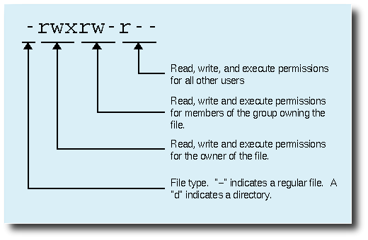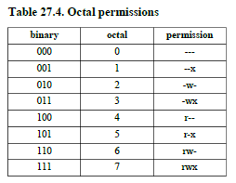

Chmod *octal getal(3x)* *path*

Bv: paul@laika:~/perms$ chmod 777 permissions.txt

paul@laika:~/perms$ ls -l permissions.txt

-rwxrwxrwx 1 paul paul 0 2007-02-07 22:34 permissions.txt

# Verbinden met zijn pc via ftp

ftp <IP>

|_examen

|_examen

Passive

ls